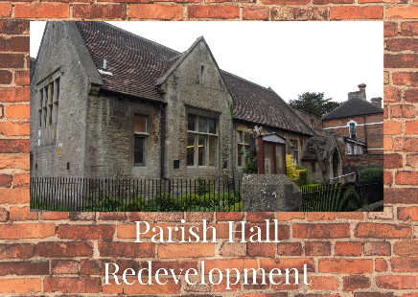
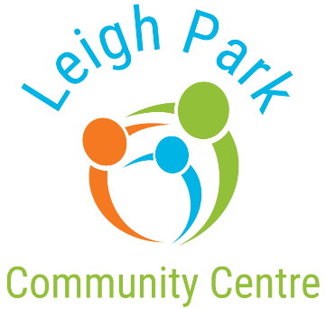
All Saints Parish Hall

Joint Public Consultation

We want to hear your views on the facilities available in Westbury and how we can help improve services for all ages of our community. This survey will help us know which facilities are missing or need improving on and help us with our continued project plans for Leigh Park Community Centre (LPCC) and All Saints Parish Hall (ASPH).
Questionnaire
What area are you from?
Westbury Westbury-Leigh Dilton-Marsh Chapmanslade Bratton
Other Please state where
What age group are you?
  - 10-17 18-21 22-30 31-49 50+

Do you know where Leigh Park Community Centre (LPCC) is? Yes No
Do you know where All Saints Parish Hall (ASPH) is? Yes No
How do you travel to Leigh Park Community Centre and / or All Saints Parish Hall?
LPCC: Car Public transportation Walk Other
ASPH: Car Public transportation Walk Other
If there was a funded mini bus for either site, would it benefit you? Yes No
How often do you visit Leigh Park Community Centre and / or All Saints Parish Hall?
LPCC: More than once a week Weekly Monthly Yearly Do not use
ASPH: More than once a week Weekly Monthly Yearly Do not use

Why do you visit Leigh Park Community Centre?

Why do you visit All Saints Church Hall?
Do you know about the regular activities being held at Leigh Park Community Centre (LPCC) and / or All Saints Parish Hall (ASPH)?
LPCC: Yes No ASPH: Yes No
Did you know we have an in-house Coffee Shop at LPCC? Yes No
Would you use a community coffee shop at All Saints Parish Hall? Yes No
Did you know that both sites have Preschools for 2–5-year-olds?
LPCC? Yes No ASPH? Yes No
How have you heard about us at Leigh Park Community Centre?
From a friend Newspaper Notice Board Facebook Other social media Newspaper I didn’t hear
How have you heard about us at All Saints Church?
From a friend Newspaper Notice Board Facebook Other social media Newspaper I didn’t hear
Please leave any comments about services you think are needed in Westbury

Leigh Park Community Centre Survey
Do you support the on-going plans for Leigh Park Community Centre proposed project of the additional land?

Can you suggest any improvement to Leigh Park Community Centre’s project plan?

Do you have any concerns about or aspects of the project plans to expand Leigh Park Community Centre?

What do you value most about living in the community?

What other activities or events would you like to see being held?

Further Information
If you have any further comments, please let us know here.

If you would like to offer your help in anyway, perhaps with our fundraising campaign, volunteering, please let us know how best to get in touch with you.
Name: | Tel:
Email:

Thank you for completing this survey
All Saints Parish Hall Survey
Do you support the redevelopment of All Saints Parish Hall?

Can you suggest any improvement to All Saints Parish Hall project plan?

Do you have any concerns about or aspects of the project plans to redevelop All Saints Parish Hall?

What do you value most about living in the community?

What other activities or events would you like to see being held?

Further Information
If you have any further comments, please let us know here.

If you would like to offer your help in anyway, perhaps with our fundraising campaign, volunteering, please let us know how best to get in touch with you.
Name: | Tel:
Email:
Thank you for completing this survey

